https://snowsportsculture.com/sold-on-andermatt/

SOLD ON ANDERMATT!
Save
Share

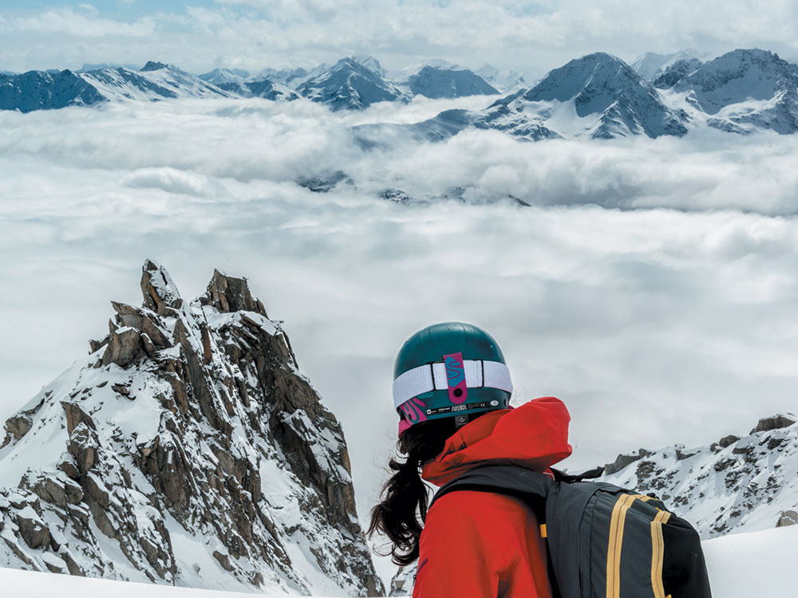

METAMORPHOSIS OF THE SWISS DESTINATION IS NEARLY COMPLETE; AUTHENTIC OLD – WORLD CHARM MEETS NEW STANDARDS TO REDEFINE THIS CLASSIC VILLAGE
BY: Julie Nieuwenhuys PHOTOGRAPHY: Caroline Van ‘T Hoff
“THE HILLS ARE ALIVE WITH THE SOUND OF MUSIC…” WE SING AS OUR TRAIN MEANDERS THROUGH THE GREEN SWISS HILLS.
We are three Dutch “powder babes” on a quest for some typical Swiss treats: mountains of cheese, chocolate, and of course our favorite snack, powder! This year, Caroline, Len and I are celebrating Easter in Andermatt and Disentis, two charming villages in the heart of the Swiss Alps.

RAILWAY TO HEAVEN
A church sits on each hilltop above the rolling lush green meadows, the iconic red and white flag waving proudly. It feels like we have stepped into a tourism brochure, the landscape recreated with Swiss precision. From the panoramic windows on board the Glacier Express we see the massive Alps appear in the distance, with snow-covered tops and Toblerone-like peaks. We have exactly four minutes to make our connection, including all our ski bags, airbags and suitcases, but it’s fine – no delays for this red train. We get out in Disentis (pronounced as “This-and-this”) and can already hear the bells ringing in the huge Benedictine monastery that dates back to 720. As the monks are called to vespers, we know that our sacred ground lies almost 2,000 meters higher, where the slopes of Disentis await.
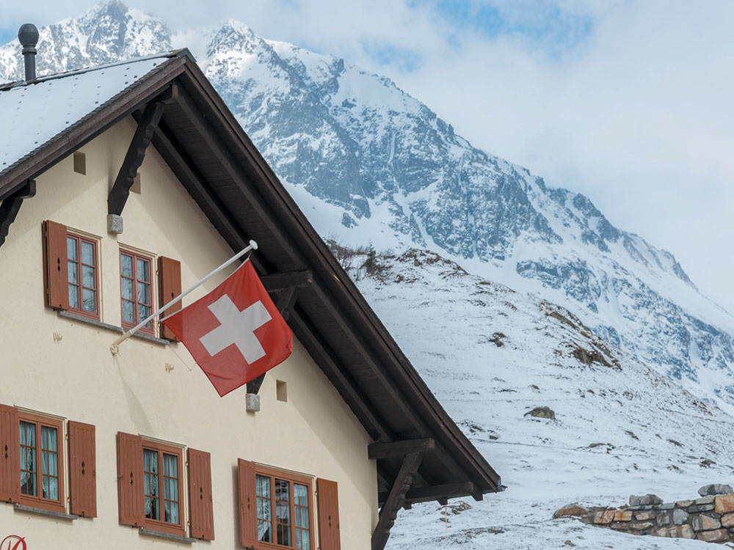

JODELAAHITII – THE ALPS IN ITS GLORY
The next morning, the trees in the valley are covered with a fresh layer of snow: our prayers have been answered! We meet Adi, our friendly Swiss guide, in a near-empty gondola. No powder stress today. In less than 15 minutes we ascend from 1,100 meters to almost 3,000, where the rugged mountains majestically tower over the clouds. Enchanted by this phenomenal view, we make our first runs through 20 centimeters of powder just beyond the quiet slopes. Pointing to a steep, untouched northern slope, Adi asks whether we feel like touring up. He doesn’t have to ask us twice, and pretty soon our skis are in touring mode and the first kick turn is quick to follow. From the top of a Swiss peak, we can look straight down into the spring green valley where cows are grazing and trees are blossoming. We conjure Swiss delicacies such as Alpine cheese and chunks of chocolate from our mobile minibar. For dessert, the virgin northern slope awaits, and we fly down it, amazed by the good quality of the snow. Before I know it, I am at the bottom of the face, adrenaline racing through my body. I cheer when Len skis up with a huge smile on her face. What a fantastic feeling!

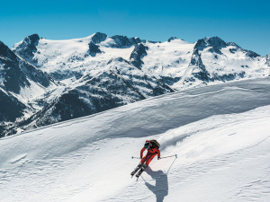

GEMSSTOCK: A FREERIDE PARADISE
As the conductor’s whistle blows – exactly on time, of course – we leave Disentis behind us. The train slowly climbs uphill, and the surrounding mountains become increasingly rougher. As we cross the Oberalp Pass, we can’t help but notice the dozens of avalanche barriers on the Gemsstock: Andermatt’s freeride mountain. Brakes squealing, our train braves the steep hairpin turns on the way to our destination, which has a population almost equal to its elevation in meters: 1,444. With its many northern slopes and spectacular terrain, Andermatt has been high on our list of dream destinations for years. The microclimate guarantees lots of snow, and sure enough the flakes have also been falling here in the past few days!
We meet our guide Marco, who sports a deep goggle tan, at the top of the Gemsstock. Before we hit the trail, we take time to admire the panoramic views. “We are in the heart of Switzerland and from here you can see half the country and about 600 peaks,” says Marco. It is truly stunning; I could spend the entire day gazing at these white giants, which look positively friendly today surrounded by blue skies. As we do a pieps check, Marco points out the various powder possibilities. I had always been under the impression that Andermatt was synonymous with serious powder battles, but this late in the season we are practically the only freeriders.
The snow is light as a feather and our spray mists and sparkles in the bright sun. We ski the best snow of the trip, and possibly the best snow that I have ever skied so late in the season. Everywhere we look we see beautiful couloirs that are no more than a short traverse, hike or tour away; an abundance of possibilities! Later, when the snow has become too heavy, it is time for a beer in the hot sun, a spring skiing must!
Cheerful German Schlager music is coming from the “Schirm,” a little bar set up in an open tent on the mountain. When Caroline decides to turn the bar into a disco, the party really gets going. Eventually, after the sun has set we all conga into the last gondola while the Swiss après-ski hit of 2014 “Ein, zwei, drei … bezoffen …” echoes deep in the valley.

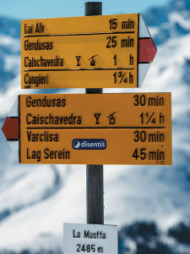THE FUTURE OF ANDERMATT
We can hardly believe our eyes the next morning when we see a Dutch city bike parked in front of the bakery. The owner is none other than Marja, a Rotterdam native who has lived here for years. Soon we are sitting down with her for breakfast and a crash course in Andermatt’s colourful history.
Up until 10 years ago, the village served as a military base, with some 70,000 soldiers stationed here. Defense not only powered the entire economy, it also took a toll on the mountains: according to Marja, the dozens of bunkers turned them into Swiss cheese. After the Cold War ended, the barracks closed and Andermatt’s future was uncertain for many years. This all changed after the Egyptian billionaire Samih Sawiris saw the unused land from his airplane and proceeded to close a megadeal. Suddenly, sleepy little Andermatt’s future looked very different. According to Samih’s plans, it will be transformed into Switzerland’s ultimate new high-end ski destination, with an emphasis on preserving the village’s authentic charm. The skiing area, too, will undergo a complete metamorphosis. For starters, three new lifts will be built to connect the Sedrun ski resort located on the east side of the Oberalp Pass with Andermatt, creating 120 kilometers of extra trails on accessible southern slopes, ideal for families. For now, the Gemsstock will be left untouched. Nearly everyone that we speak to in Andermatt – like Marco and Marja – are extremely optimistic about Samih’s plans. In 2007, 96 percent of the local residents voted in favor of these investments. Of course, it remains to be seen whether this massive investment will ever be recovered, even with the advent of foreign buyers and the proximity to both Zurich (110 km) and Milan (180 km). But one thing is assured: Andermatt is a unique village that is no stranger to reinvention. Whether it is the snow, the landscape, or the renewed sense of hope, something is thriving in Andermatt … we are sold!
